**Khushal Soni coding challenge 1 – Tableau**

Question 1: -

**Affordable and Expensive Cities**

* Amsterdam is most expensive city with an average weekday price of 573 Pounds, and average price on weekends is around 60 Pound higher than that of weekdays.
* Athens is the most affordable place with an average price of 152 Pounds, and average price on weekends is around 8 Pounds lesser than that of weekdays.

Question 2: -

**Comparison between Weekdays and Weekend**

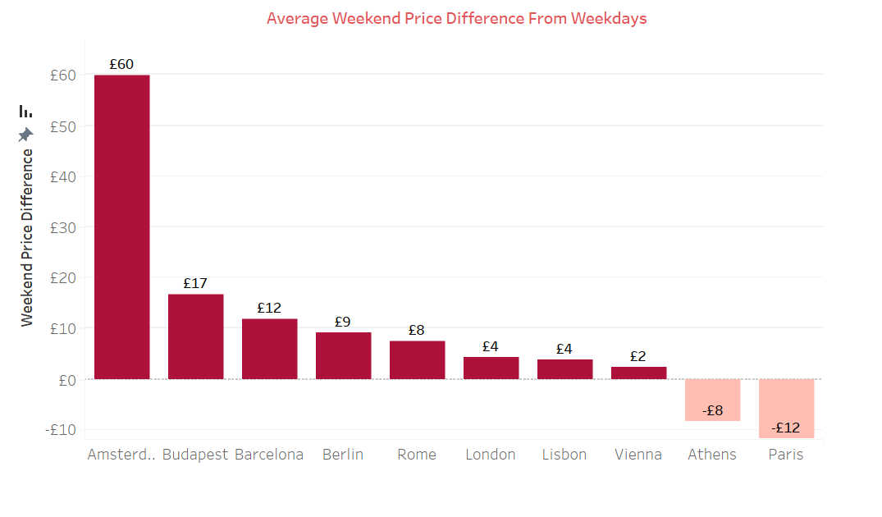

* The above graph shows comparison between average price on weekend and weekdays across different cities with Amsterdam having highest price difference and Paris having least price difference.

Question 3: -

**Important determinants of Airbnb prices**

* Average Overall guest satisfaction and cleanliness ratings are almost same for all places. Hence these doesn’t affect the Airbnb price listings.
* Average price is higher for Entire home/ Apartments bookings in every city, for six number of bedrooms price is way higher than others. Listings having more person capacity has higher price which indicates more spacious properties has higher price.
* Price is high when Airbnb listing property is near to metro or near to centre of city.
* Distance from city centre and metro, room type, number of bedrooms, person capacity affects the price.

Question 4: -

**Important drivers in booking occupancy**

* The most preferred booking option is a one-bedroom room Entire Apartment or Private Room. The second most preferred option is a Two-bedroom Entire Apartment.
* In almost all places, people do not prefer a shared room.
* London has the highest number of bookings (9993) with an average price of 362 pounds, while Amsterdam has the least number of bookings(2080) with an average price of 573 pounds.